IST769 Homework Submission Template

Basic Information
Your Name: Holden Herrell
Your SUID: 502591291
Your Email: hwherrel@syr.edu
Date Due: 11/16/2019
Homework #: 7

Instructions
For each answer, please include your answer as text, and any screenshot(s) which demonstrate your answer was executed. Most importantly, make sure to include evidence your answer is correct. This will most likely be a screenshot. If you had issues, problems, or had to make assumptions include them in your answer.

Your Answers:
1a. 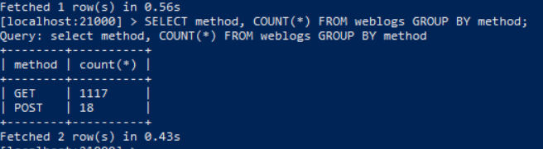
There were 1117 GET requests and 18 POST requests in the weblogs.

1b.
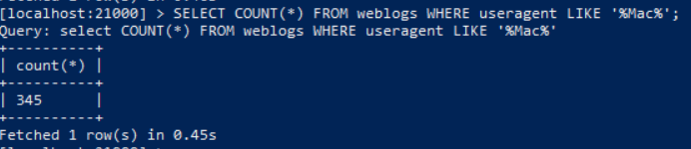
There are 345 requests with Mac in the user agent.

1c.
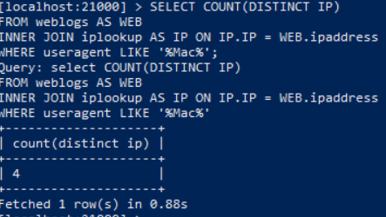
There are 4 ip addresses with Mac in the user agent.

2a.
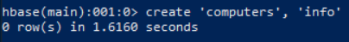
2b.
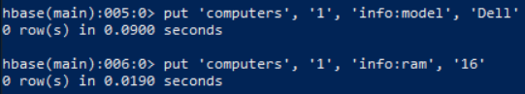
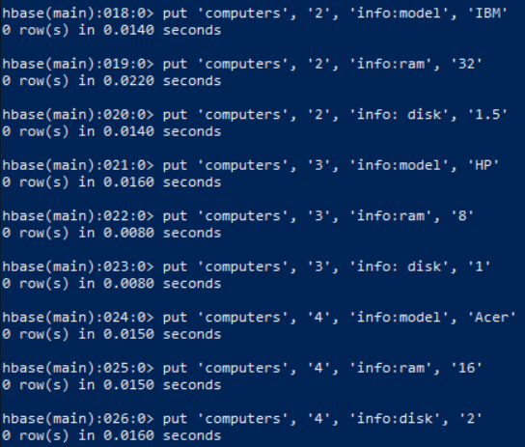
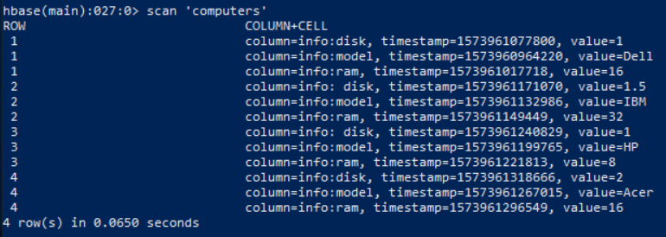

3.
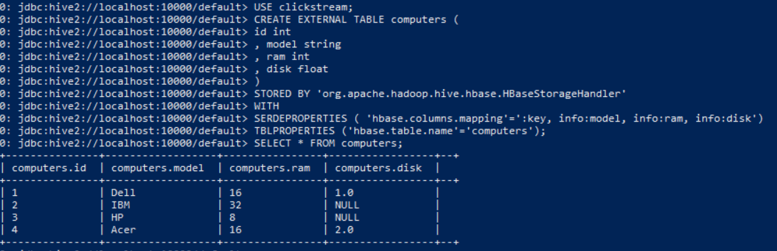
I’m not really sure what happened to the values in the disk column for records 2-3 on this one. It’s like they disappeared when they were present in #2 (see screenshot).
4.
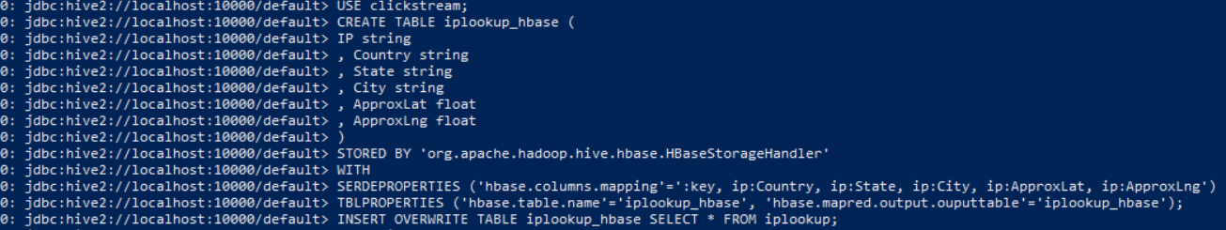
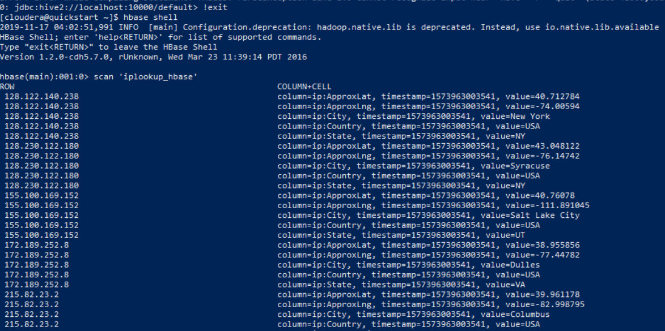

5.
